**Hotel Reservation System**

**Design Document**

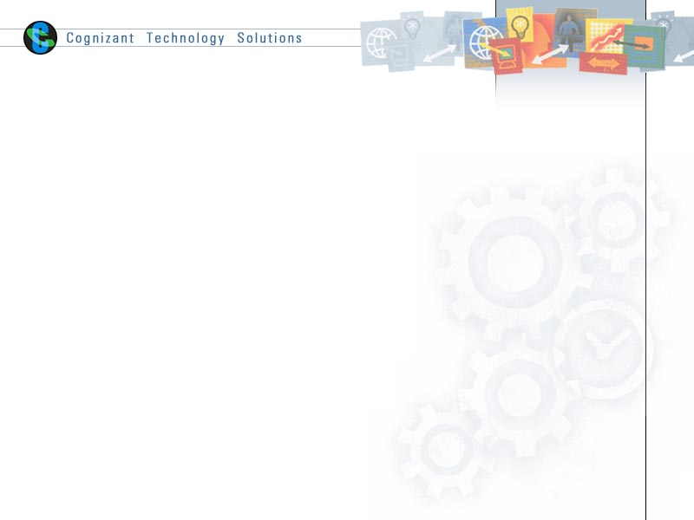

|  |  |  |  |
| --- | --- | --- | --- |
|  | **Prepared By** | **Reviewed by** | **Approved By** |
| **Name** | Sanjiv Mishra  Soumen Chowdhury  Ankit Raj  Kshatriya Prabu |  |  |
| **Role** |  |  |  |
| **Signature** |  |  |  |
| **Date** | 25/04/19 |  |  |

Table of Contents

1.0 Introduction 3

1.1 Purpose of this document 3

1.2 Scope 3

1.2.1 In Scope 3

1.2.2 Out Scope 3

1.3 Intended Audience 3

1.4 References 3

2.0 Assumptions, Dependencies and Risks 4

3.0 System Architecture 4

4.0 Use Case Realization 5

4.1 Flow of Events – Design 5

4.1.1 User Sequence – Web Based 5

4.1.2 Admin Sequence – Web Based 6

4.2 Class Diagram – Design 7

4.2.1 Class Diagram – Console Based 7

4.3 Component Descriptions 8-12

5.0 Database Design 13

5.1 Identification of DDL, DML and PL/SQL objects 13

5.2 Table Structure 13

5.3 E- R Diagram (Relationship between Tables) 16

6.0 Screen-shots 17-18

# Introduction

## Purpose of this document

The purpose of the software requirements document is to systematically capture requirements for the project and the system “Hotel Reservation System” to be developed. Both functional and non-functional requirements of this system are captured in this document. It also serves as the input for the project scoping.

## Scope

### In Scope

* Hotel Add/Edit/Delete/View
* Hotel Search/Reserve
* Reservation Edit/Cancel
* Registration and Authentication
* Payment

### Out Scope

* Migration of customer list into the application

## Intended Audience

The intended audience for this document is

* Developers, testers, other associates in the project
* Client
* Delivery Assurance Group, Process Engineering group

## References

* <http://www.beautifullife.info/web-design/15-best-free-hotel-templates/>
* http://www.tutorialspoint.com/uml/uml_class_diagram.htm

# 

# Assumptions, Dependencies and Risks

**Assumptions**:

* Once the website is built it will manually load the current customer list into the system.
* The hotel and customer profile will be maintained by the Admin.
* Any changes to the design post sign-off would be taken as a Change Request.

**Dependencies**

NA

**Risk**

* Any delay in obtaining the sign-off for the design would have an impact in the schedule of the project.

# System Architecture

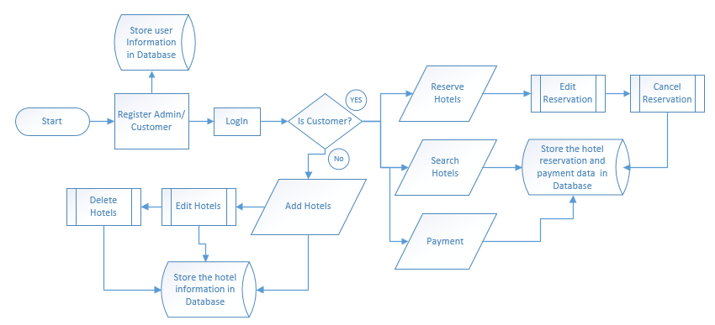

Fig 3.1: System Architecture

# Use Case Realization

## Flow of Events – Design

### User Sequence –Web Based

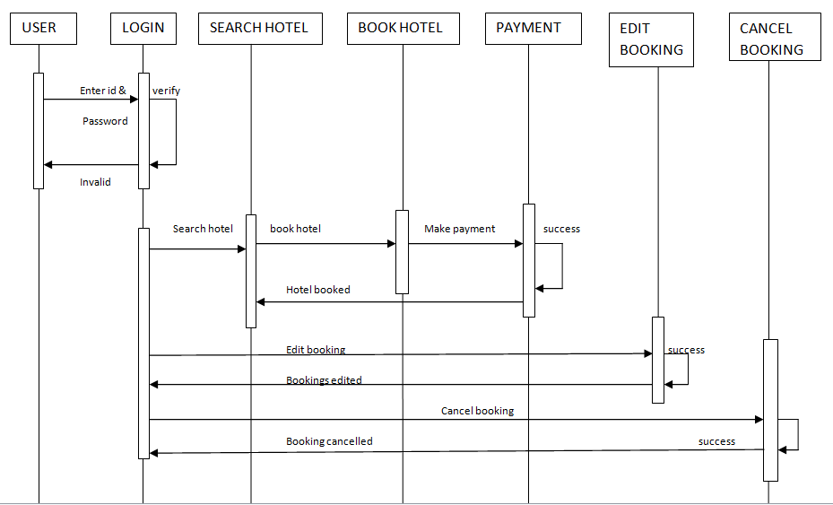

Fig 4.1: Use Case Diagram (User)

### Admin Sequence – Web Based

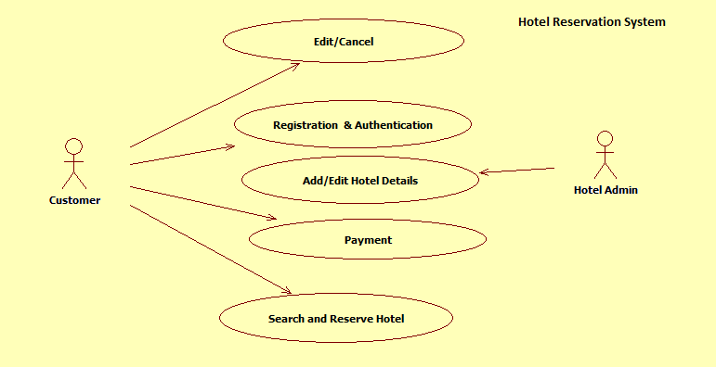

Fig 4.2: Use Case Diagram (Admin)

## Class Diagrams – Design

### Module –Web Based

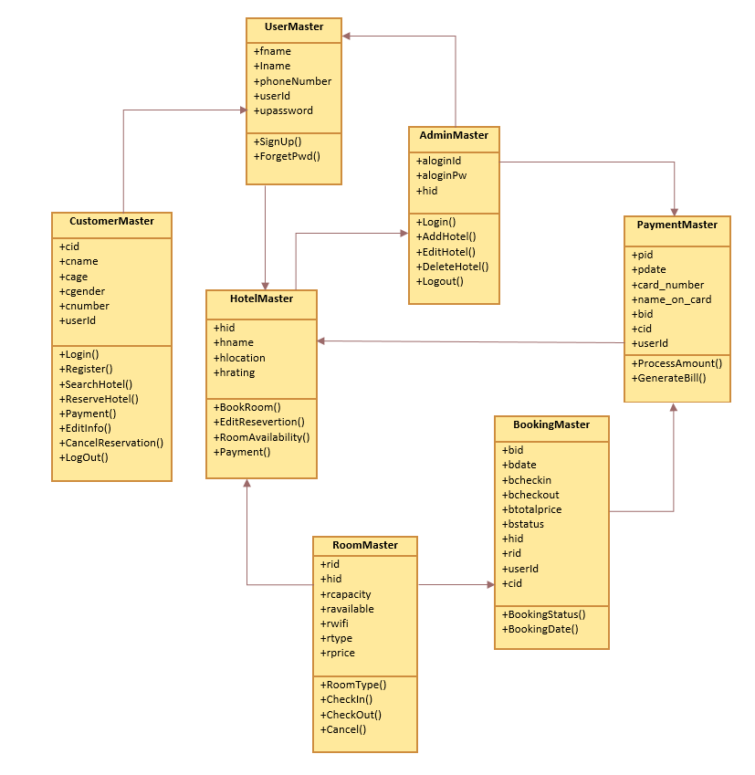

Fig 4.3: Class Diagram

## Component Descriptions

|  |  |  |
| --- | --- | --- |
| **Class** | **Method** | **Program Logic** |
| **Webpage** | **login()**  **Parameters**  Username  Password  **Return Type**  void | Accepts the username and password. |
| **logout()**  **Return Type**  void | Direct to the homepage |
| **register()**  **Return Type**  Void | Direct to the class customer to enter the customer detail.  Calls the register method in class customer. |
| **validatepwd()**  **Return Type**  void | Displays the message if the customer enters the wrong password. |
| **register()**  **Return Type**  Void | Direct to the class customer. |
| **Customer** | **editInfo()**  **Return Type**  void | edit the detail of the customer |
| **Admin** | Public bool ValidateAdmin() | Admin can add new hotel |
| **hotel** | Public EditHotelDl() | * Hotel name,id,rating will be available for public |

|  |  |  |
| --- | --- | --- |
| **RoomBooking** | **checkIn()**  **parameter**  checkInDate  rate  **ReturnType**  void | * Updates the entry date |

# Database Design

## Identification of DDL, DML and PL/SQL objects

## Table Structure

|  |  |  |  |  |  |  |
| --- | --- | --- | --- | --- | --- | --- |
| Table Name | Column Name | Column Discription | Data Type | Data Size | Primary Key | Other Constraint |
| CustomerMaster | C_ID | Column is used for storing customer id | VARCHAR | 200 | YES | NOT NULL |
| C_NAME | Column is used for storing customer name | VARCHAR | 200 | NO | NOT NULL |
| C_AGE | Column for storing customer age | VARCHAR | 200 | NO | NOT NULL |
| C_GENDER | Column is used for storing customer gender | VARCHAR | 200 | NO | NOT NULL |
| C_NUMBER | Column is used for storing customer number | VARCHAR | 200 | NO | NOT NULL |
| USER_ID | Column for storing Customers user_id | VARCHAR | 200 | NO | FOREIGN_KEY |
| UserMaster | F_NAME | Column is used for storing users first name | VARCHAR | 200 | NO | NOT NULL |
| L_NAME | Column is used for storing users last name | VARCHAR | 200 | NO | NOT NULL |
| PHONE_NUMBER | Column is used for storing users phone number | VARCHAR | 200 | NO | NOT NULL |
| USER_ID | Column is used for storing user_id | VARCHAR | 200 | YES | NOT NULL |
| USER_PASSWORD | Column is used for storing users password | VARBINARY | 200 | NO | NOT NULL |
| HotelMaster | H_ID | Column is used for storing hotel Id | VARCHAR | 200 | YES | NOT NULL |
| H_NAME | Column is used for storing hotel name | VARCHAR | 200 | NO | NOT NULL |
| H_LOCATION | Column is used for storing hotel location | VARCHAR | 200 | NO | NOT NULL |
| H_RATING | Column is used for storing hotel rating | VARCHAR | 200 | NO | NOT NULL |
| RoomMaster | R_ID | Column is used for storing room Id | VARCHAR | 200 | YES | NOT NULL |
| H_ID | Column is used for storing hotel Id | VARCHAR | 200 | NO | FOREIGN KEY |
| R_CAPACITY | Column is used for storing room capacity | VARCHAR | 200 | NO | NOT NULL |
| R_AVAILABLE | Column is used for storing room available | BIT |  | NO | NOT NULL |
| R_WIFI | Column is used for storing room wifi | BIT |  | NO | NOT NULL |
| R_TYPE | Column is used for storing room type | VARCHAR | 200 | NO | NOT NULL |
| R_PRICE | Column is used for storing room price | MONEY |  | NO | NOT NULL |
| BookingMaster | B_ID | Column is used for storing booking id | VARCHAR | 200 | YES | NOT NULL |
| B_DATE | Column is used for storing booking date | DATE |  | NO | NOT NULL |
| B_CHECKIN | Column is used for storing checkin date | DATETIME |  | NO | NOT NULL |
| B_CHECKOUT | Column is used for storing checkout date | DATETIME |  | NO | NOT NULL |
| B_TOTALPRICE | Column is used for storing totalprice | MONEY |  | NO | NOT NULL |
| B_STATUS | Column is used for storing booking status | BIT |  | NO | NOT NULL |
| H_ID | Column is used for storing hotel id | VARCHAR | 200 | NO | FOREIGN KEY |
| R_ID | Column is used for storing room id | VARCHAR | 200 | NO | FOREIGN KEY |
| USER_ID | Column is used for storing user id | VARCHAR | 200 | NO | FOREIGN KEY |
| C_ID | Column is used for storing customer id | VARCHAR | 200 | NO | FOREIGN KEY |
| PaymentMaster | P_ID | Column is used for storing payment id | VARCHAR | 200 | YES | PRIMARY KEY |
| CURRENT_BAL | Column is used for storing current bal | MONEY | 40000 | NO |  |
| CARD_NUMBER | Column is used for storing card number | VARCHAR | 200 | NO |  |
| NAME_ON_CARD | Column is used for storing name on card | VARCHAR | 200 | NO |  |
| USER_ID | Column is used for storing user id | VARCHAR | 200 | NO | FOREIGN KEY |
| AdminMaster | A_LOGIN_ID | Column is used for storing admin id | VARCHAR | 200 | NO |  |
| A_LOGIN_PW | Column is used for storing admin login password | VARBINARY |  | NO |  |
| H_ID | Column is used for storing hotel id | VARCHAR | 200 | NO | FOREIGN KEY |
| transactionDetails | TRANSACTION_ID | Column is used for storing transaction id | VARCHAR | 50 | YES | PRIMARY KEY |
| P_ID | Column is used for storing payment id | INT |  | NO | FOREIGN KEY |
| USER_ID | Column is used for storing user id | VARCHAR | 200 | NO |  |
| CARD_NUMBER | Column is used for storing card number | VARCHAR | 50 | NO |  |
| AMOUNT_DEBIT | Column is used for storing amount debited | MONEY |  | NO |  |
| AMOUNT_CREDIT | Column is used for storing amount credited | MONEY |  | NO |  |

## E- R Diagram (Relationship between Tables)

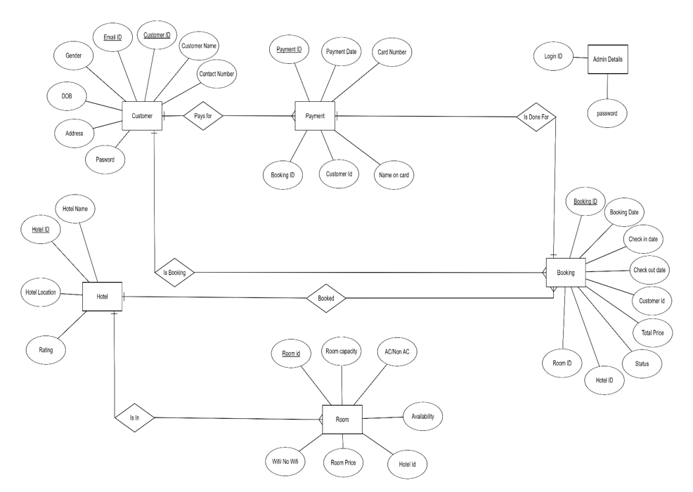

Fig 5.1: E-R Diagram

# Screenshots:

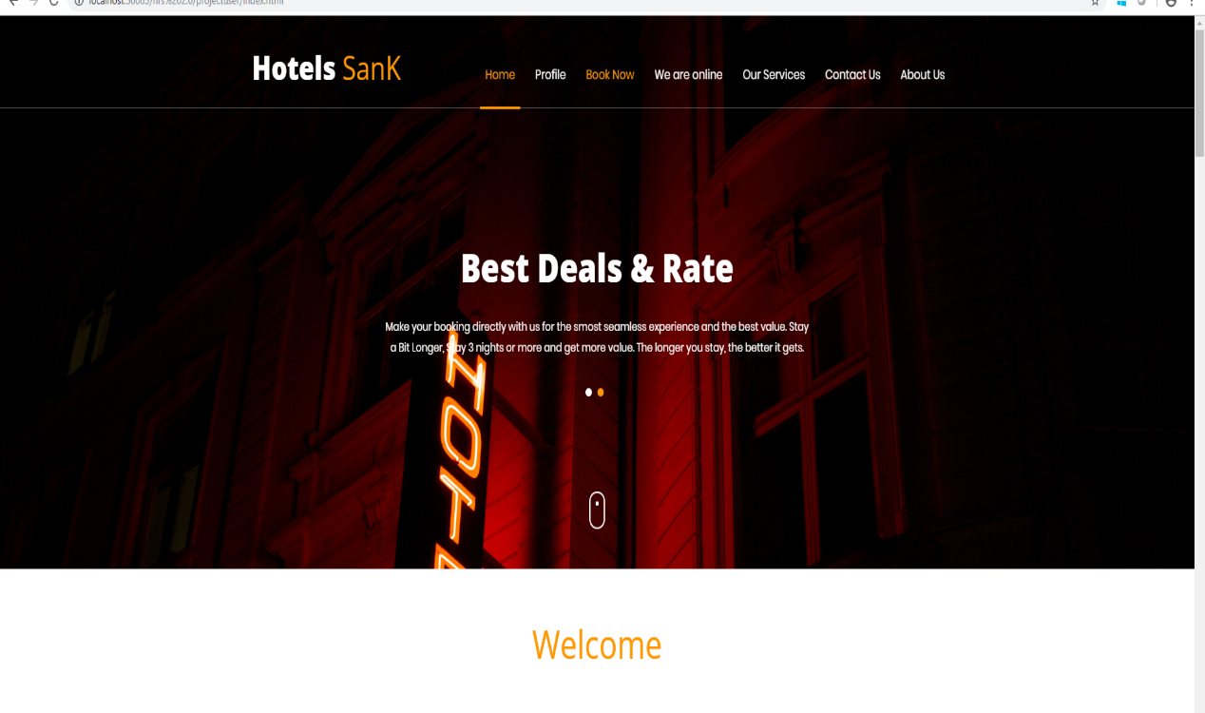 Fig 6.1: Home Page

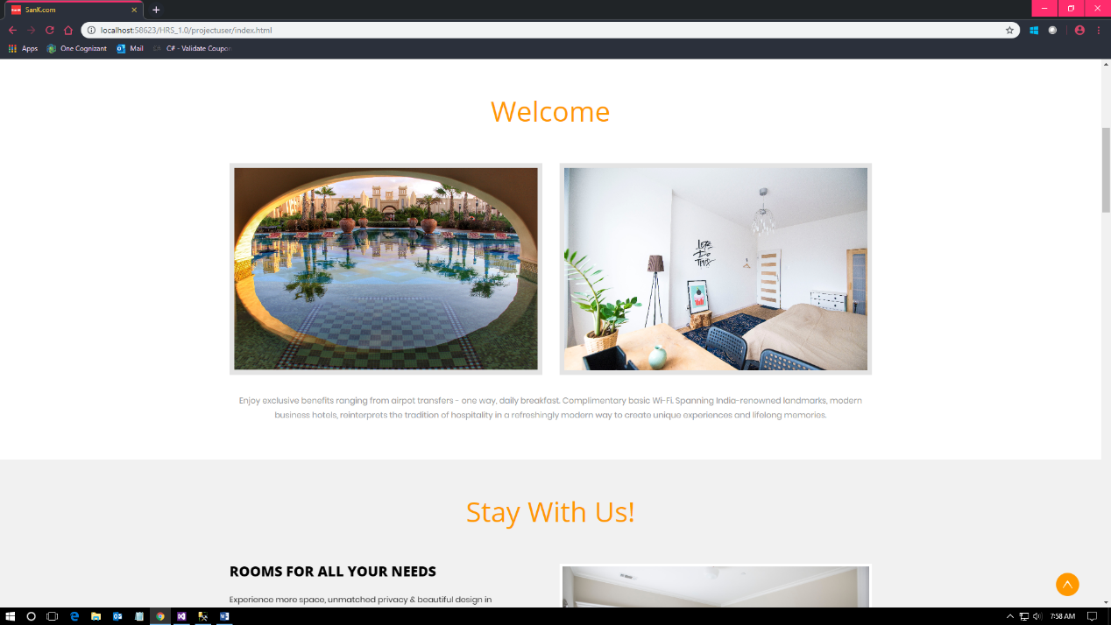

Fig 6.2: Home Page

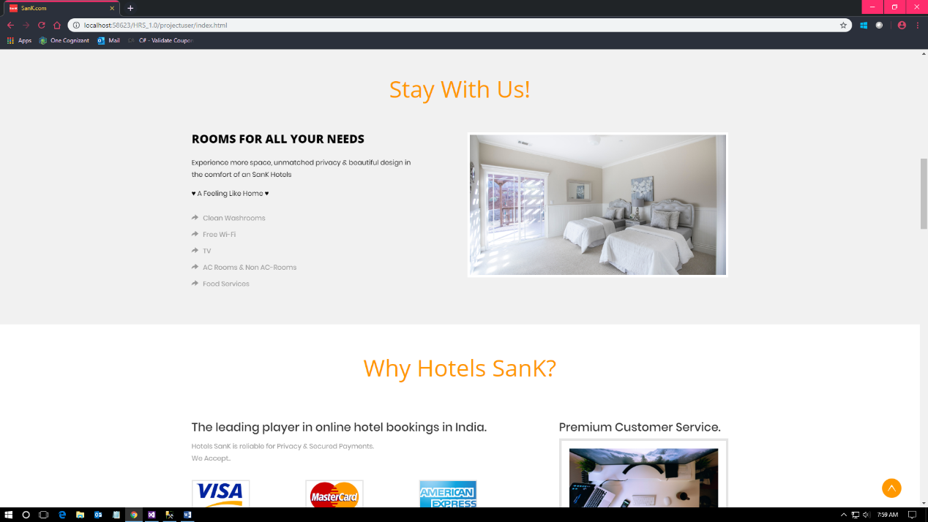

Fig 6.3: Home Page

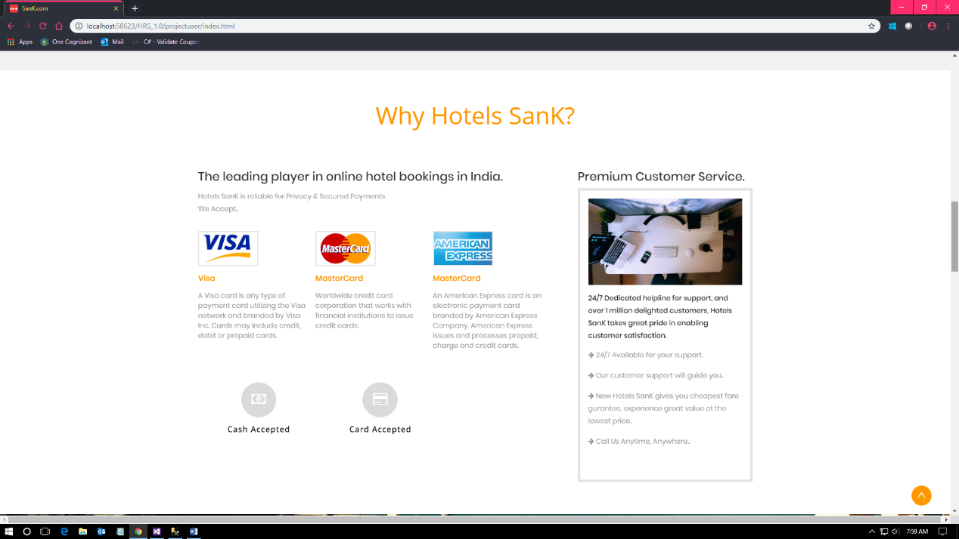

Fig 6.4: Home Page

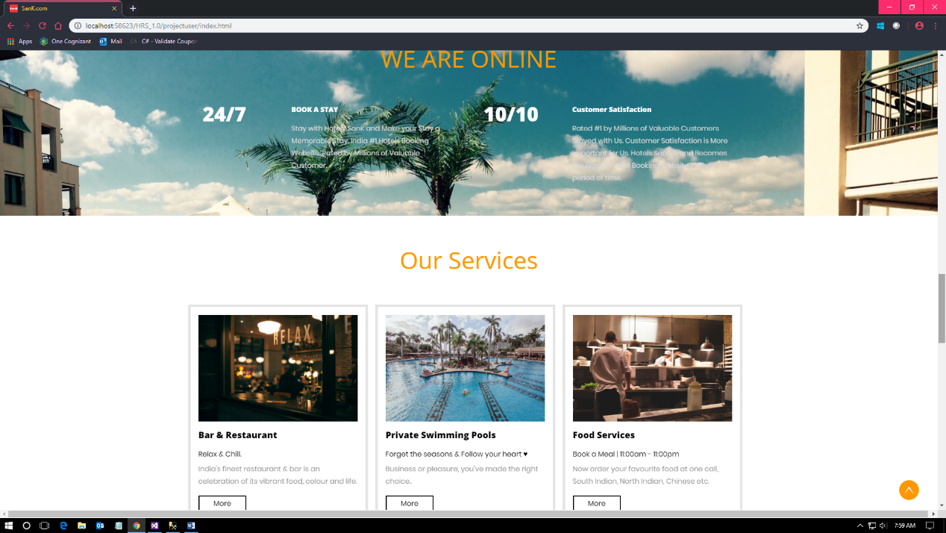

Fig 6.5: Home Page

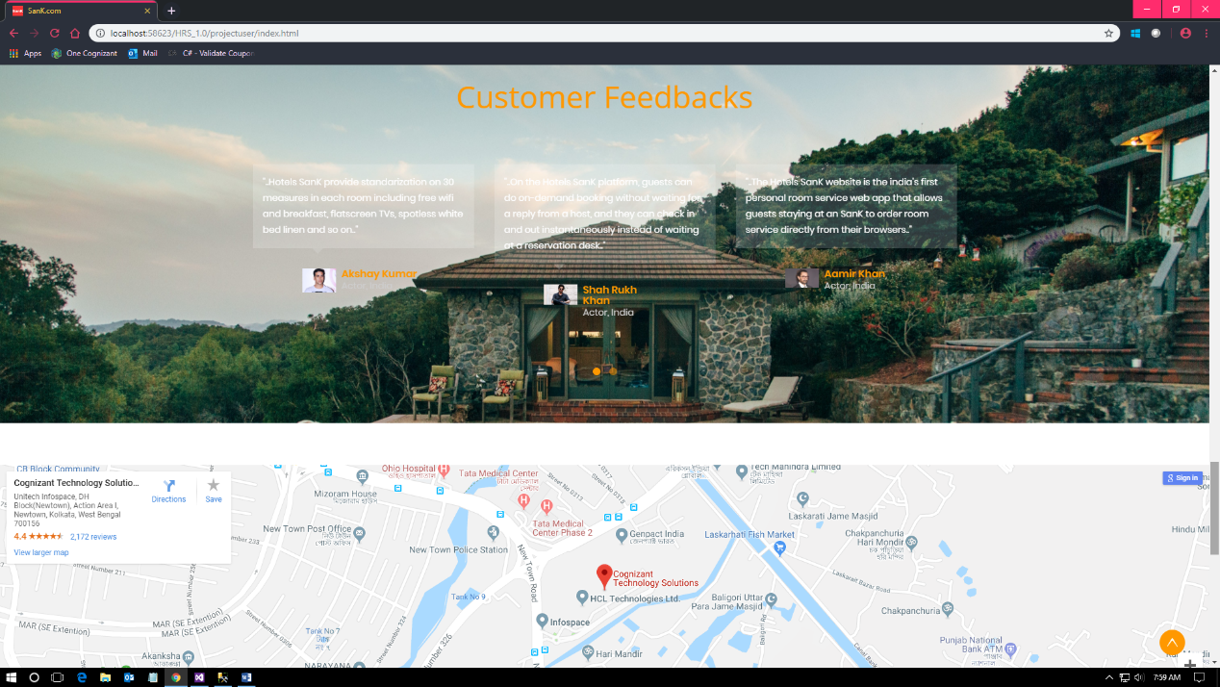

Fig 6.6: Home Page

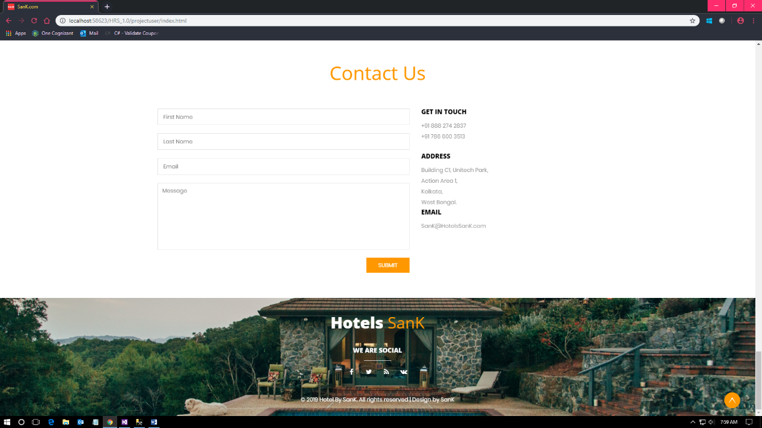

Fig 6.7: Home Page

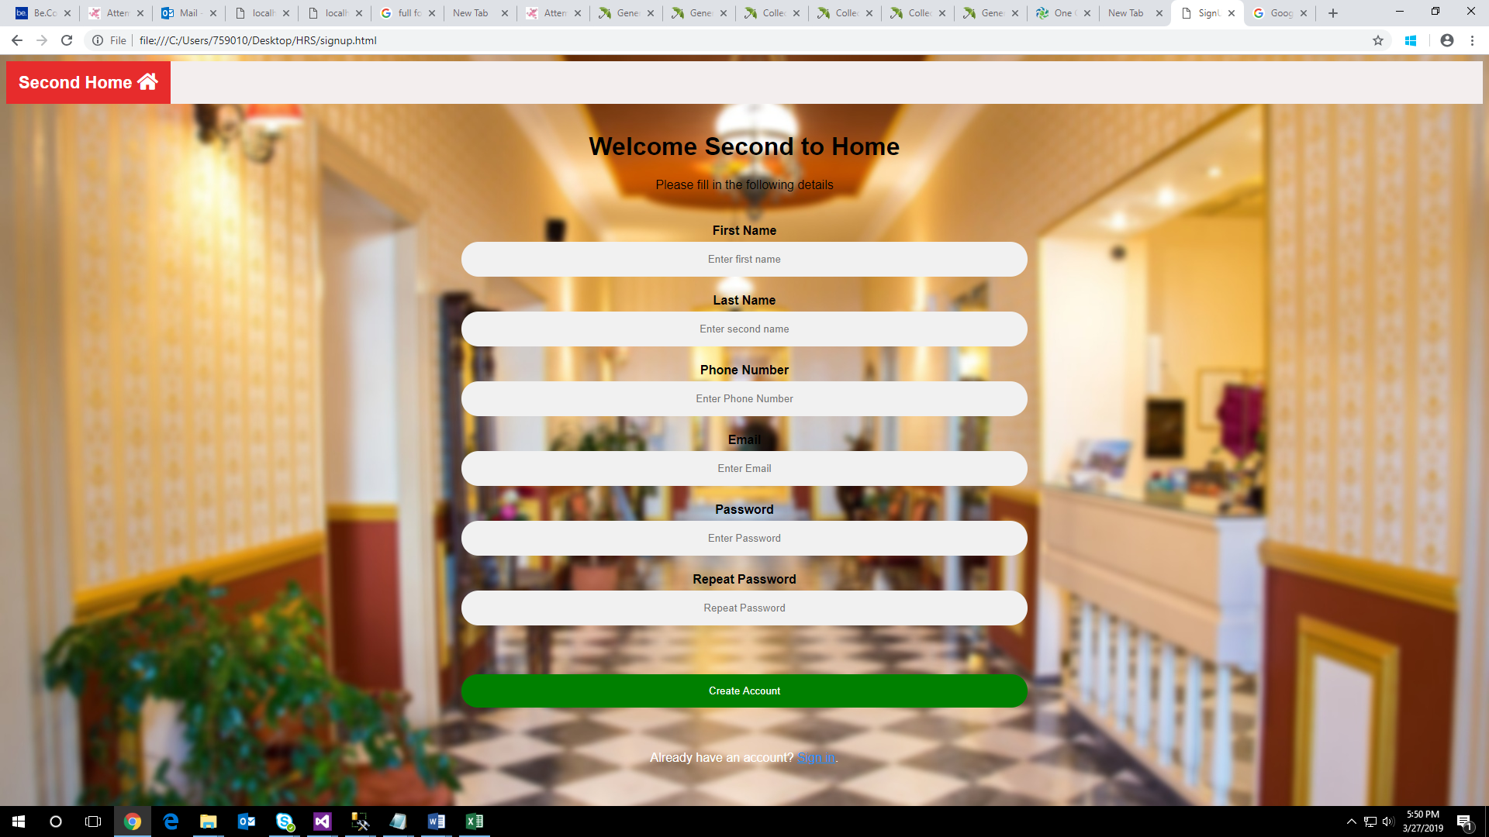

Fig 6.8: Registration Page:

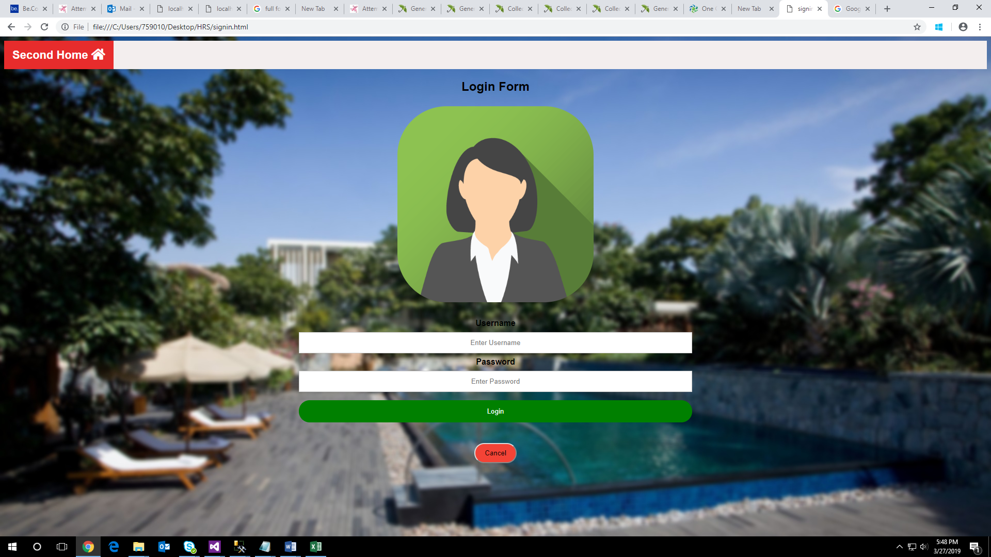

Fig 6.9: Login Page

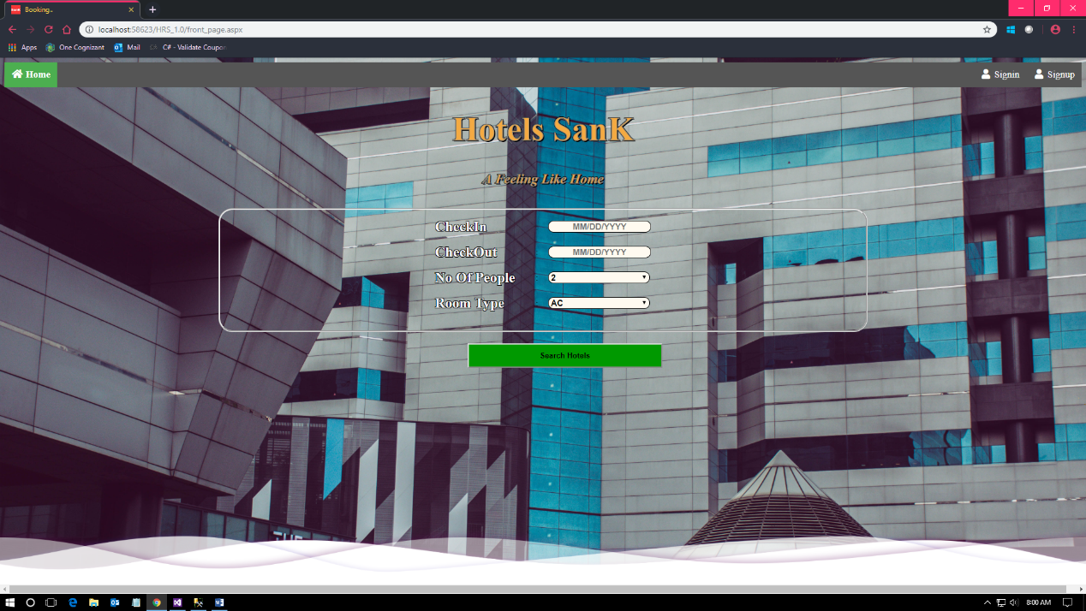

Fig 6.10: Checkin Page

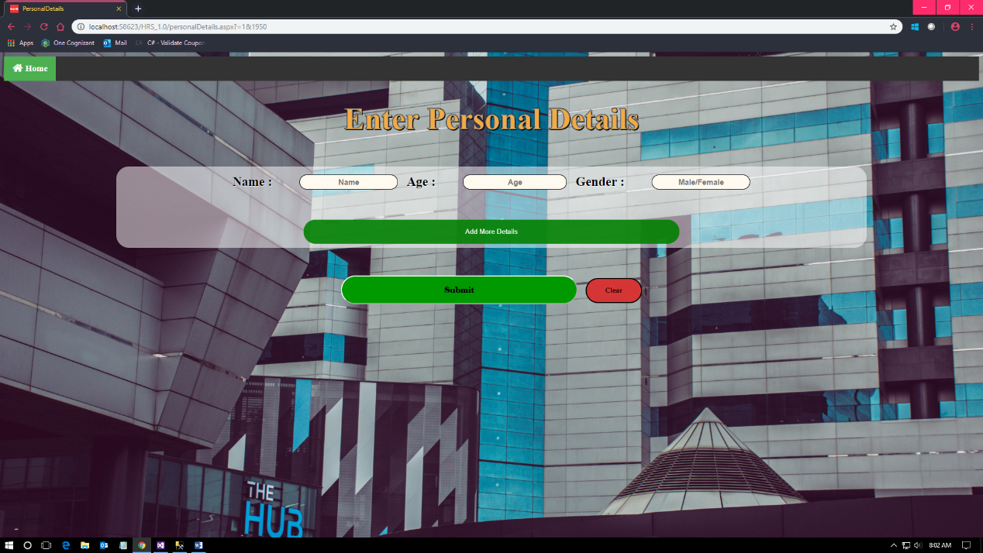

Fig 6.11:Personal Details Page

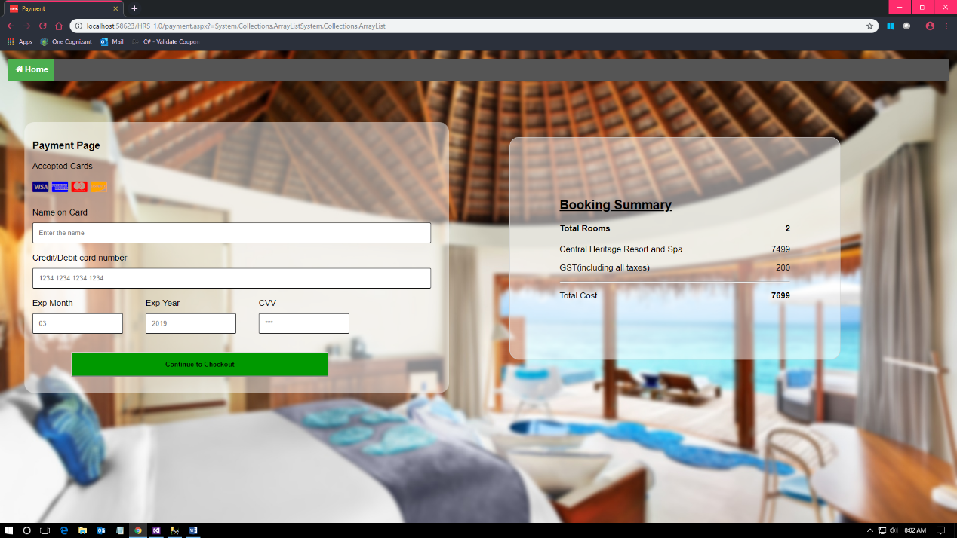

Fig 6.12:Payment Page

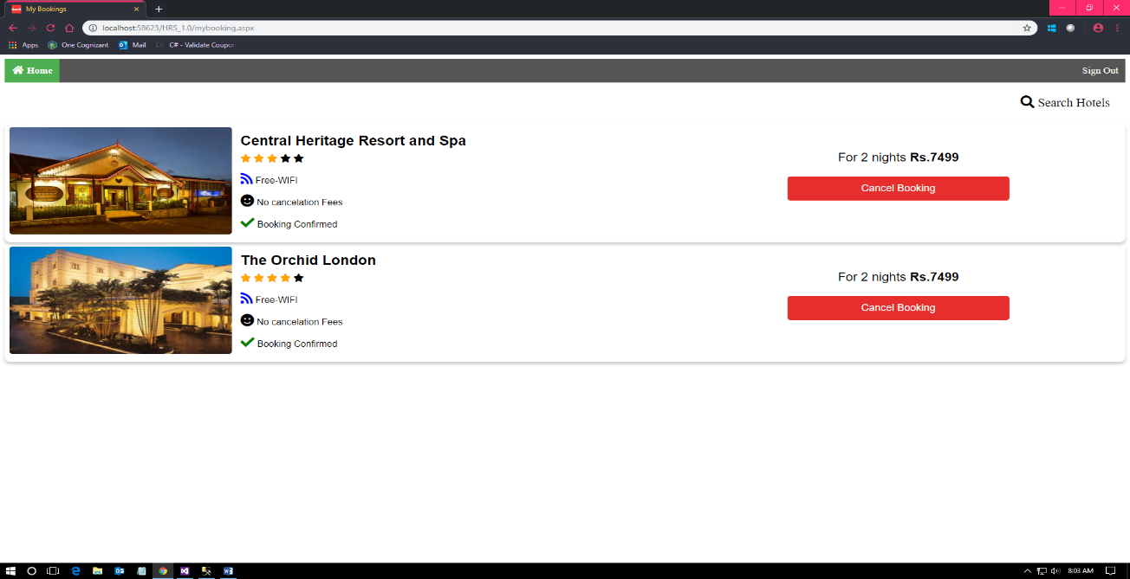

Fig 6.13: Booking Page

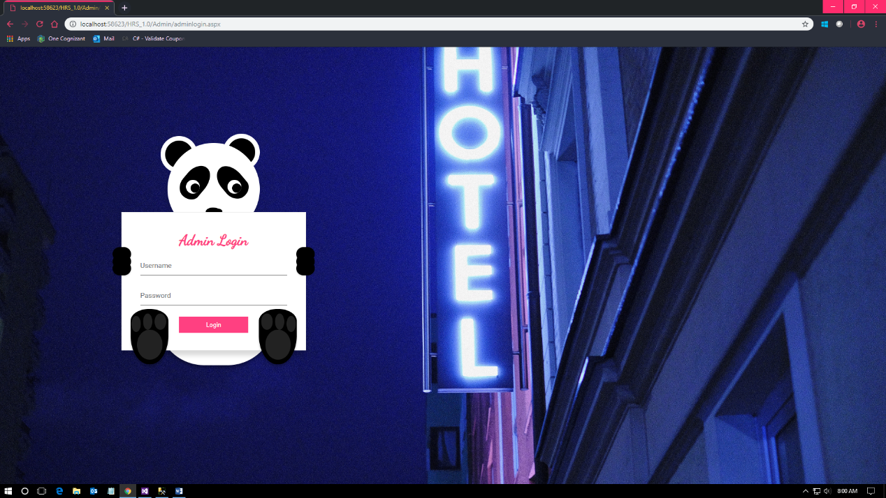

Fig 6.14: Admin Page

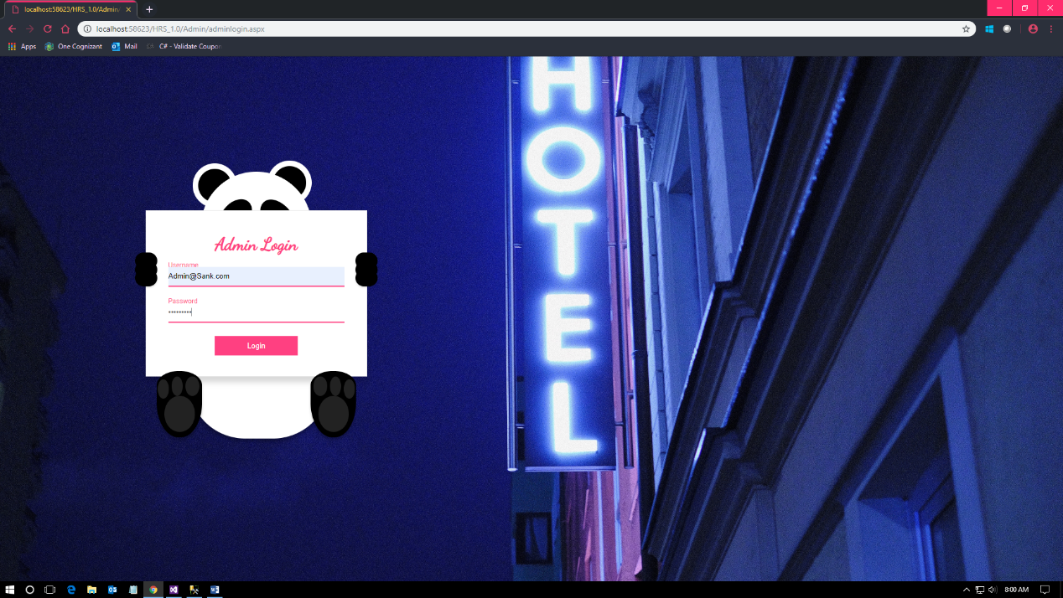

Fig 6.15: Admin Page

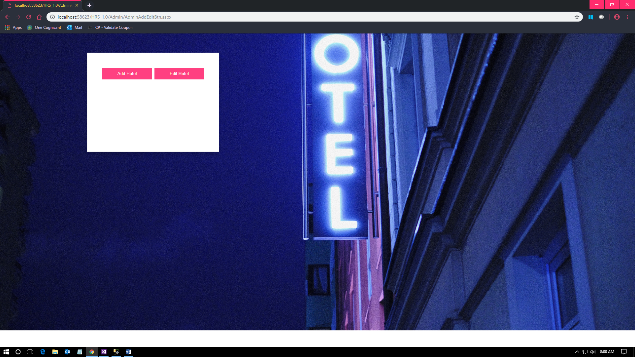

Fig 6.16: Admin Page

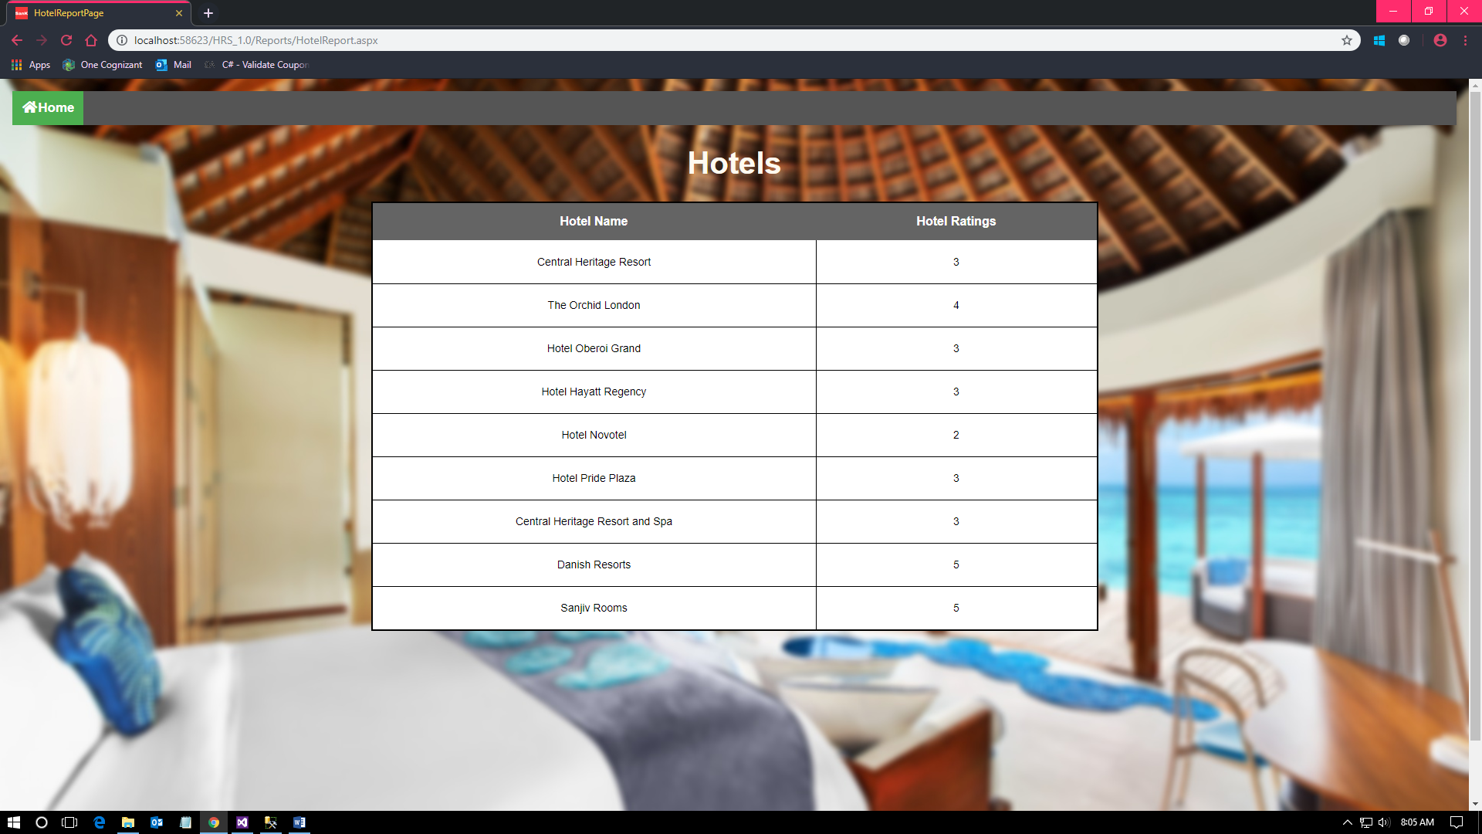

Fig 6.17: Hotels Report Page

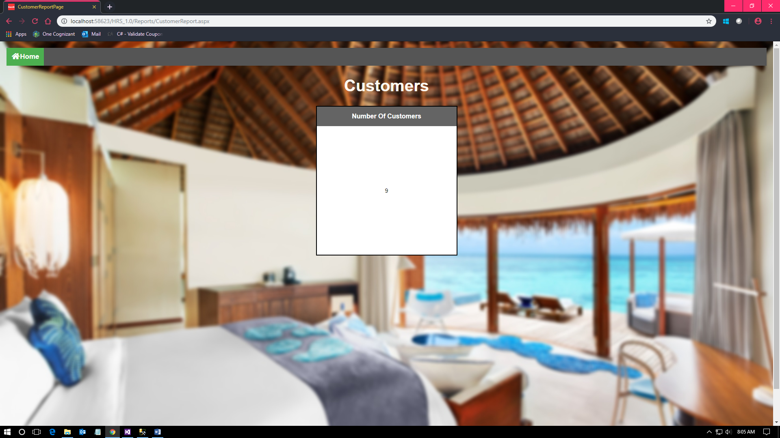

Fig 6.18: Customer Report Page

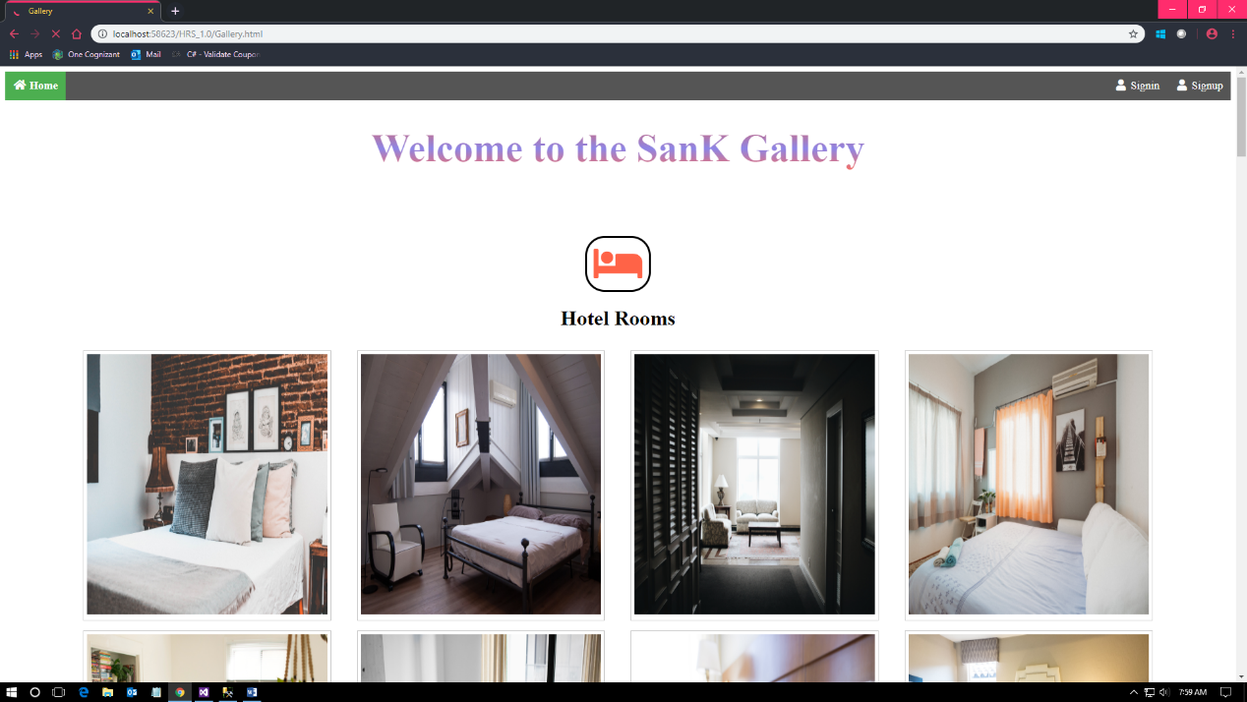

Fig 6.19: Gallery Page

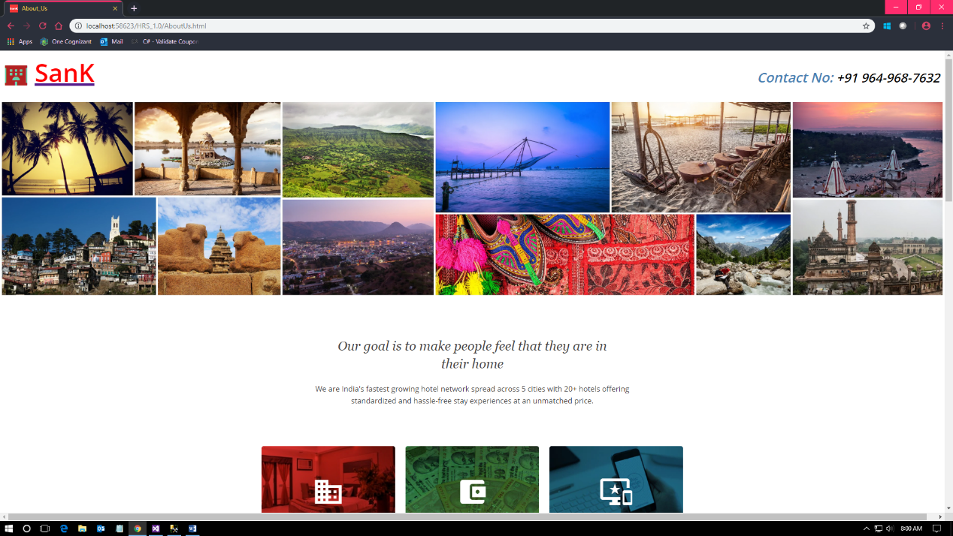

Fig 6.20: About us Page